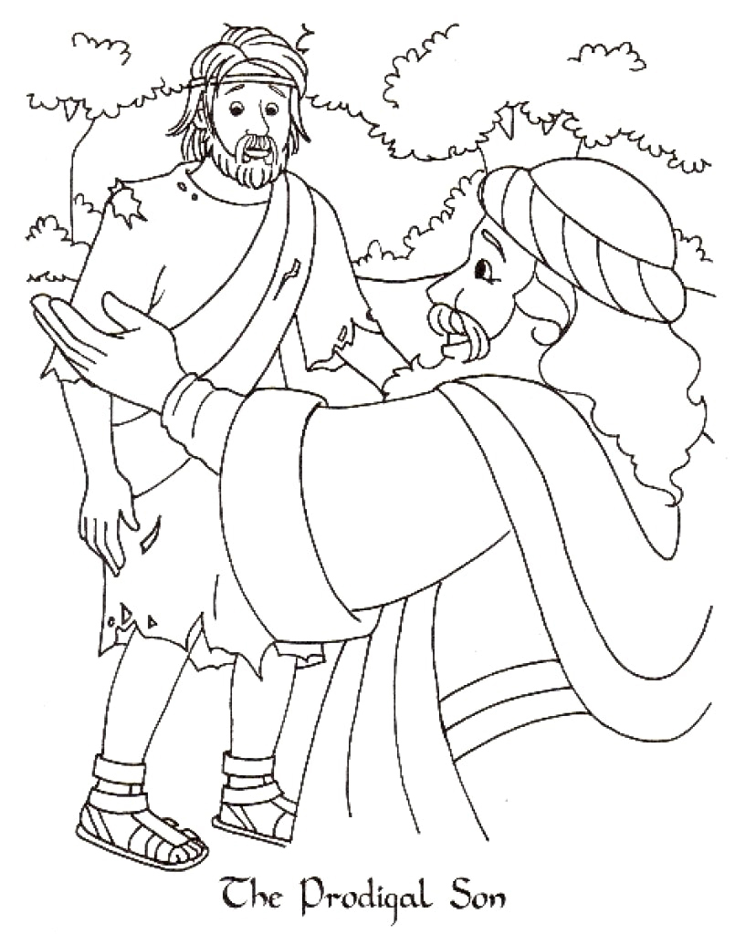

Memory verse :
“My son was dead and is alive again; he was lost and is found.” Luke 15: 24

